PDC Lab 3 Report
Advait Deochakke
20BCE1143

1) First Private

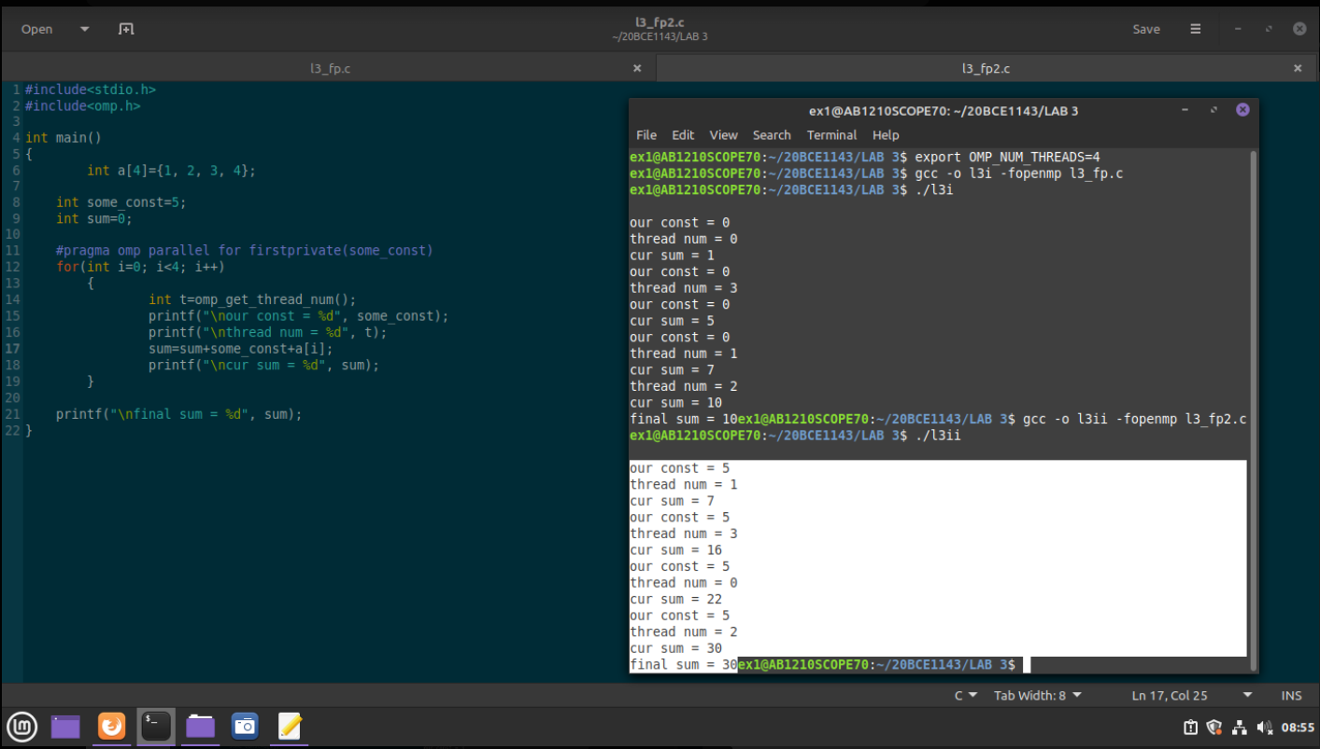

2) Last Private
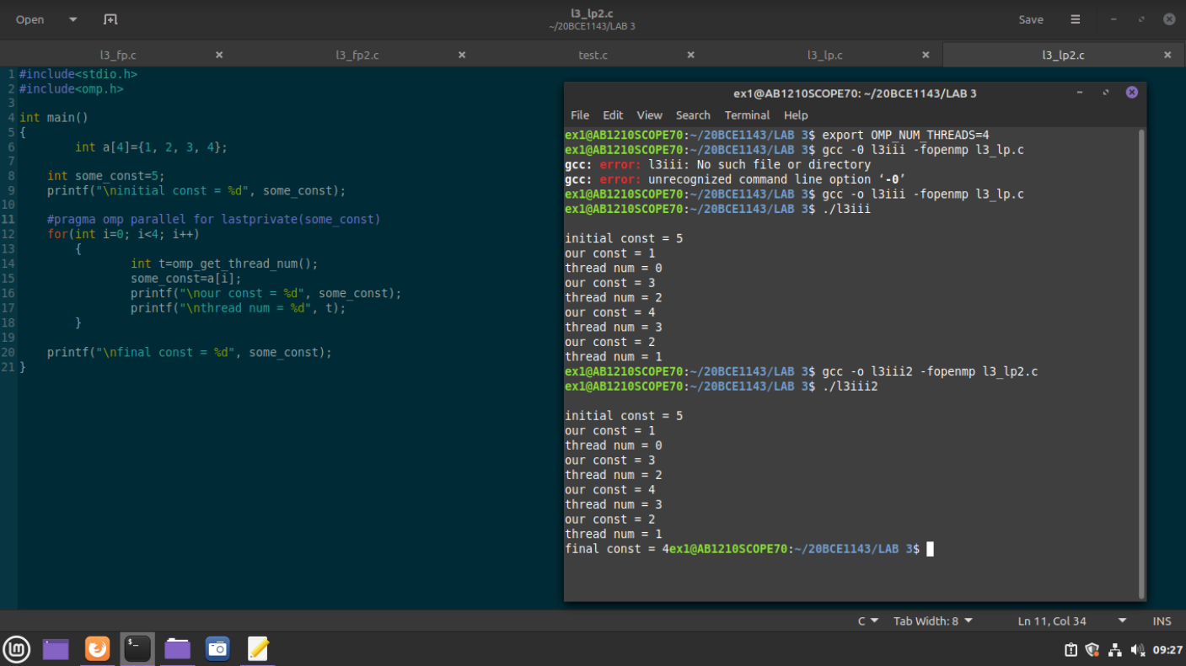

3) First Private with modification to privated variable
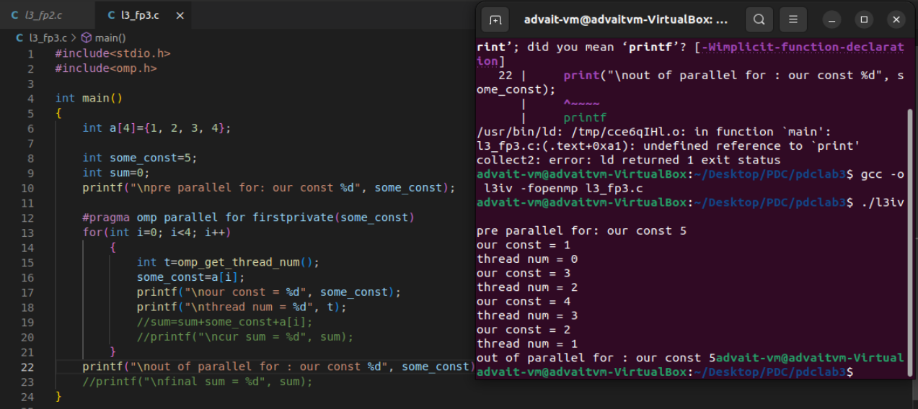

4) Sum of array c[i]

